News Sentiment Analysis

First, we built a sentiment analysis module using DeepSeek. The prompt was carefully designed to include keyword extraction, allowing the model to simultaneously identify important terms and topics within each article. We also record which companies are mentioned in each news piece.

Next, we apply a custom dictionary to classify the news into six predefined topics:
- Supply Side
- Demand Side
- Financial Risk (accounting-based recessions)
- Geopolitical Risk
- ESG Regulation
- Natural Factors (e.g., weather)

Compared to traditional LDA (Latent Dirichlet Allocation) approaches — which first cluster articles and then interpret the meaning of each cluster — our method starts with clear thematic definitions. We believe that beginning with well-defined topics leads to more interpretable and actionable classifications.

Finally, in data processing:
- We aggregate article-level information into a quarterly format.
- We generate statistics such as total mentions and sentiment distributions both with and without topic classification.
- For topic-based analysis, we consider both LDA-detected dominant topics and dictionary-assigned topics, but focus mainly on the dictionary approach due to its better clarity.
- Data is grouped either by ticker (company) or solely by quarter, depending on the specific analysis needs.

This structured pipeline ensures that the final dataset captures the sentiment, topics, company mentions, and time dynamics of the news flow in a coherent and research-ready manner.

How We Do:
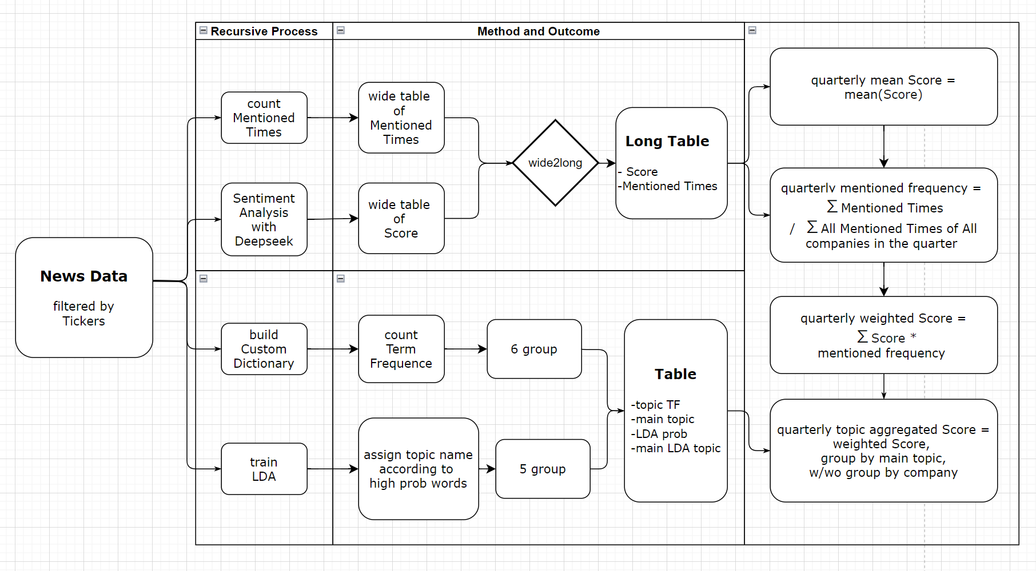

Main Reference:
Text-based crude oil price forecasting: A deep learning approach
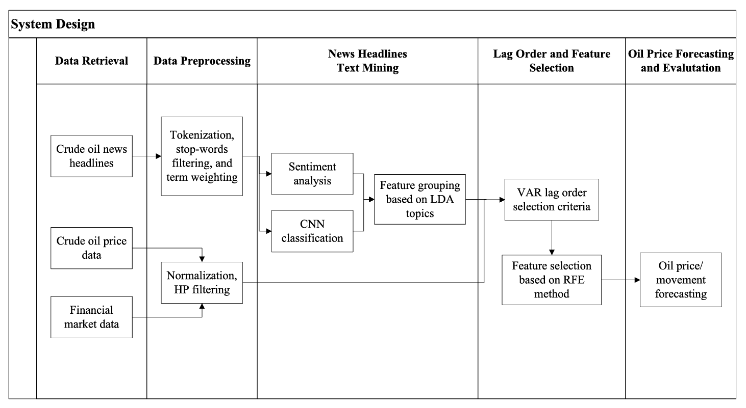
Main Idea of This Article: The sentiment features extracted from news text, along with those generated by the CNN model, show significant relationships with price changes. Furthermore, by proposing a feature grouping method based on the LDA topic model to distinguish the effects of different news topics, the model outperforms older benchmarks. In other words, instead of using a single "sentiment score," they use topic-specific sentiment features, such as "sentiment score under Weather" and "sentiment score under Stock Market." This approach increases the feature dimensions and helps capture more detailed information.

Explanation: The author team manually reviewed the highest-probability words under each LDA topic and assigned names to the topics accordingly. In the end, the paper only used a few main categories like "Weather and Natural Gas" and "Stock Market" (although the "Weather" category is somewhat vague; based on our dictionary model, it would more precisely refer to ESG concerns triggered by weather changes or cooling events, and supply-demand shifts caused by newly developed oil and gas pipelines — we attempted a finer classification). Although LDA identified four topics, the other two categories contained very few instances (we also have this issue in LDA).

